

Assignment on 18th Nov. 2017

Database

R.M.Kulani Lakshika | Dise | 024

* Databases

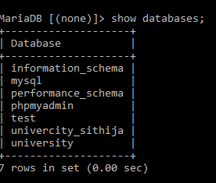

* Create department table.

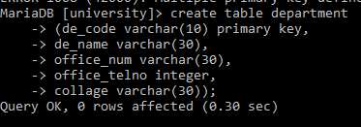

* Create course table.

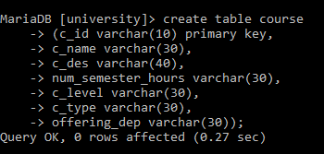

* Create pre requirements table.

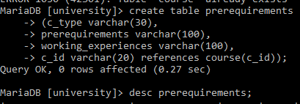

* Create section table.

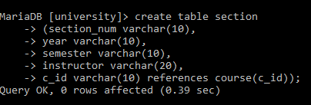

* Create grade table.

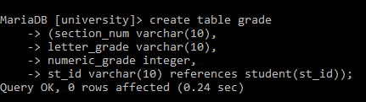

* Create student table.

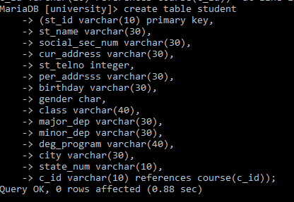

Inserting records.

Inserting records into department.

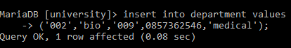

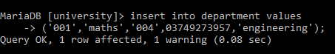

Inserting records into course.

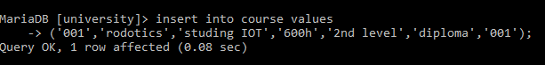

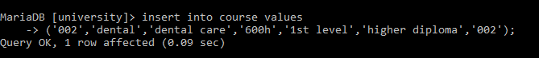

Inserting records into pre requirements.

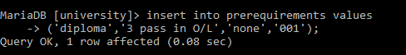

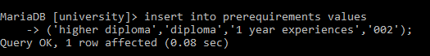

Inserting records into section.

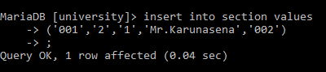

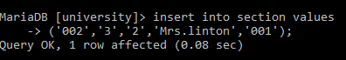

Inserting records into grade.

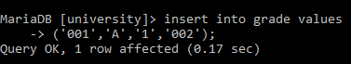

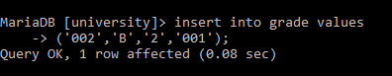

Inserting records into student.

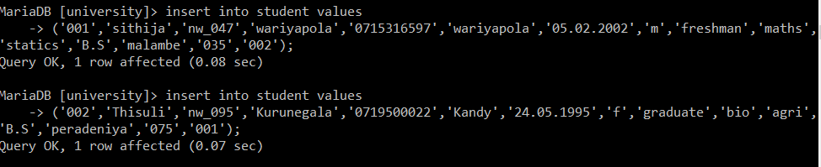

Tables

Department table.

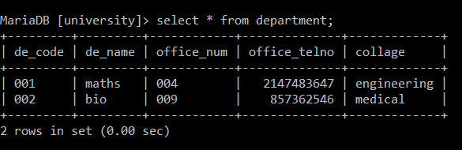

Course table.

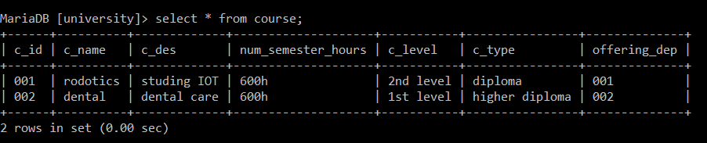

Pre requirements table.

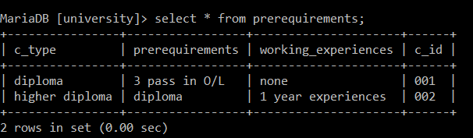

Section table.

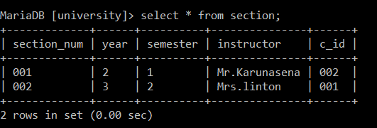

Grade table.

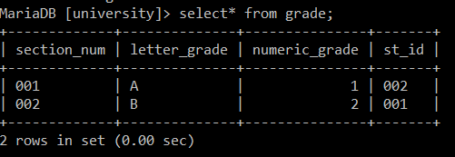

Student table.

